OVERVIEW
This job aid is designed for all agencies with access to the Consumers Energy Portal for Agency Self-Service (CE PASS). The intent of this document is to provide a concise version of the comprehensive CE PASS job aid, focusing on the most common issues and questions. By offering a streamlined resource, we aim to help users quickly find solutions and effectively navigate the portal.
If there are still questions, please contact The Energy Assistance Team at: energyassistance@cmsenergy.com. Any questions regarding the CARE programs please contact: poboxcare@cmsenergy.com.
Created by: Melissa Benzenberg and Consuelo Gomez 3/1/2025
Table of Contents
ACCOUNT STATUS DEFINITIONS 2
AMOUNT TO PAY IF DISCONNECTED WITH MOVE OUT DATE OF 12/31/9999 3
AMOUNT TO PAY IF MOVE OUT DATE IS NOT 12/31/9999 4
ENTER AN ELGIBILITY HOLD 5
ENTER A COMMITMENT HOLD 6
DELETE A COMMITMENT 7
FAQs and Additional Information 9

ACCOUNT STATUS DEFINITIONS
Status | Definition
Current | Customer’s account is up to date. There is no past due.
Past Due | Customer’s account has a past due balance.
Shut Off Pending | Customer has a past due balance that has exceeded the amount/time allowed. They are now in danger of being shut off unless the “Shut Off Balance” is paid. This amount can be found under the “Details” tab in CE PASS.
Disconnected | The customer has been disconnected and will not be turned back on until the Shut Off Balance is paid, or a commitment is made in CE PASS.
Inactive | The customer has been disconnected, and the account has had no activity on it. After 10 days of inactivity, the system turns the account “Inactive” and “Moves Out” the service for that address. Which means the account has been closed and the customer will need to pay the full balance to start a new account and to restore services. A new account number will be assigned when the services are restored. The customer may physically still live at the account at this time, this just means the account was closed.

AMOUNT TO PAY IF DISCONNECTED WITH MOVE OUT DATE OF 12/31/9999

Navigate to the “Details” tab in CE PASS.

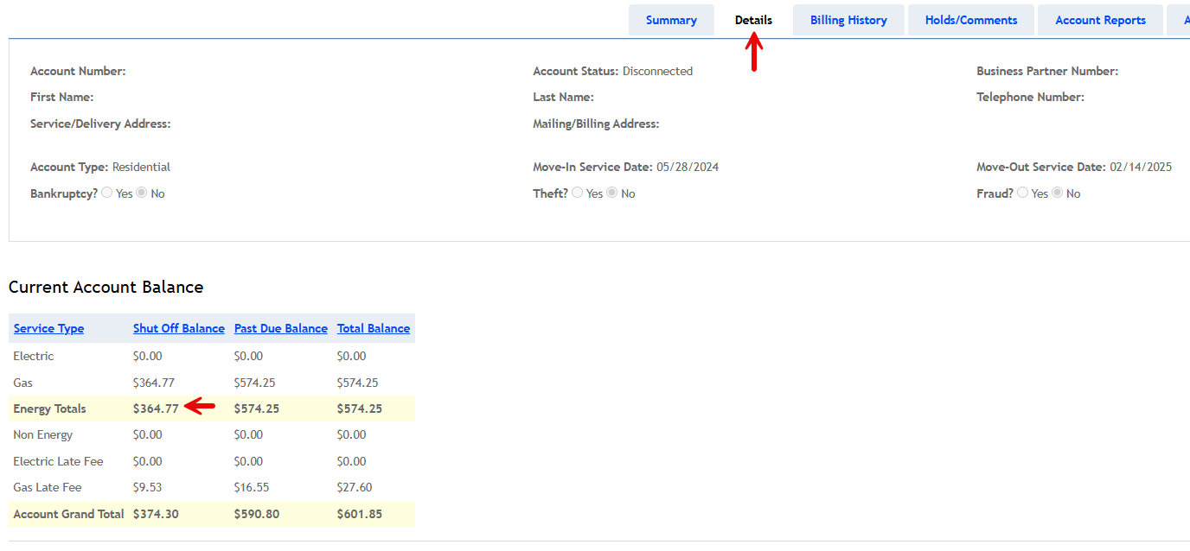
- To reconnect, the customer is required to pay the amount in the “ENERGY TOTALS” section of “SHUT OFF BALANCE”. If you need a gas/electric breakdown, you will also see it here.
- When an agency or DHHS is providing assistance, non-energy and late fees are waived.
- Once the commitment is placed in CE PASS, for the amount required or more, the customer can then call Consumers Energy Customer Service at 800-477-5050. Customer service will see the commitment and work to restore services.

AMOUNT TO PAY IF MOVE OUT DATE IS NOT 12/31/9999

Your screen will look like this in CE PASS under the Details Tab:

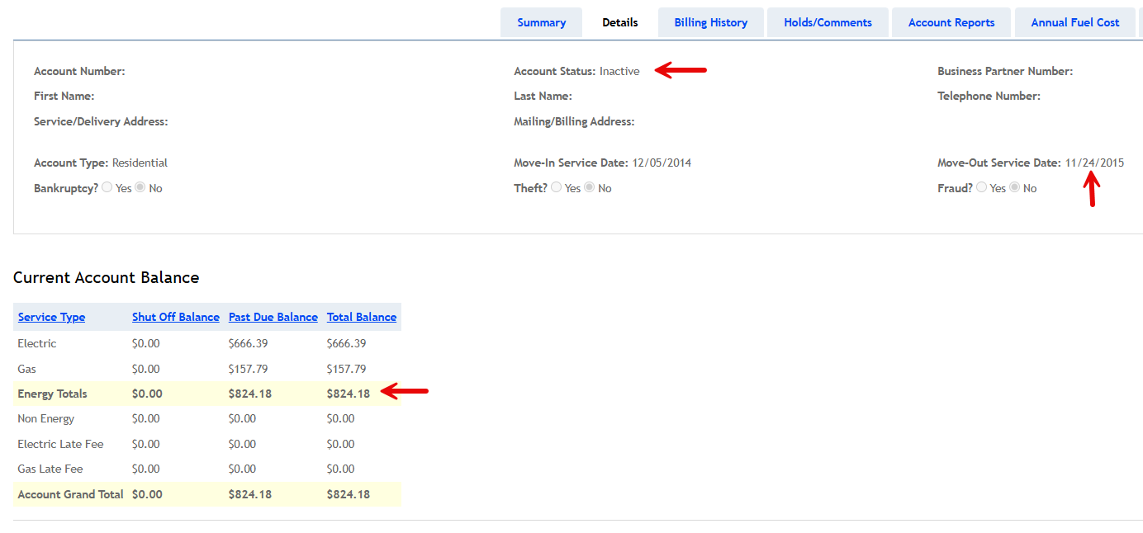
- To be reconnected or start new services, the customer is required to pay the amount in the “ENERGY TOTALS” section of “TOTAL BALANCE”. If you need a gas/electric breakdown, you will also see it here.
- When an agency or DHHS is providing assistance, additional non-energy fees and late fees are waived.
- Once the commitment is placed in CE PASS, for the amount required or more, the customer can then call Consumers Energy Customer Service at 800-477-5050. Customer service will see the commitment and work to restore services or start the customer’s new account.

ENTER AN ELGIBILITY HOLD
- In CE PASS, navigate to the “Holds/Comments” tab in the customer’s account.
- In the section, “SET ELIGIBILITY REVIEW HOLD”, enter hold comments and click on “SUBMIT 30 DAY HOLD”.

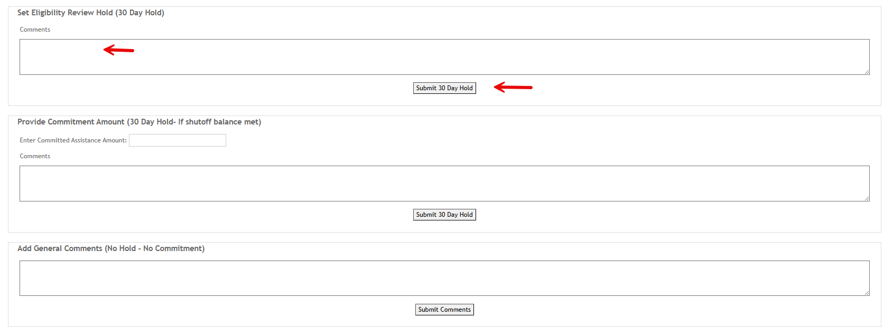
- A pop-up box will appear, click OK.

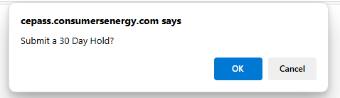
- Once the hold is placed, you will see confirmation of it, with your agency name and your name.

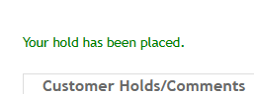

ENTER A COMMITMENT HOLD
- In CE PASS, navigate to the “Holds/Comments” tab in the customer’s account.
- In the section, “PROVIDE COMMITMENT AMOUNT”, enter your committed assistance amount (no dollar signs) and hold comment(s). Click on “SUBMIT 30 DAY HOLD”.

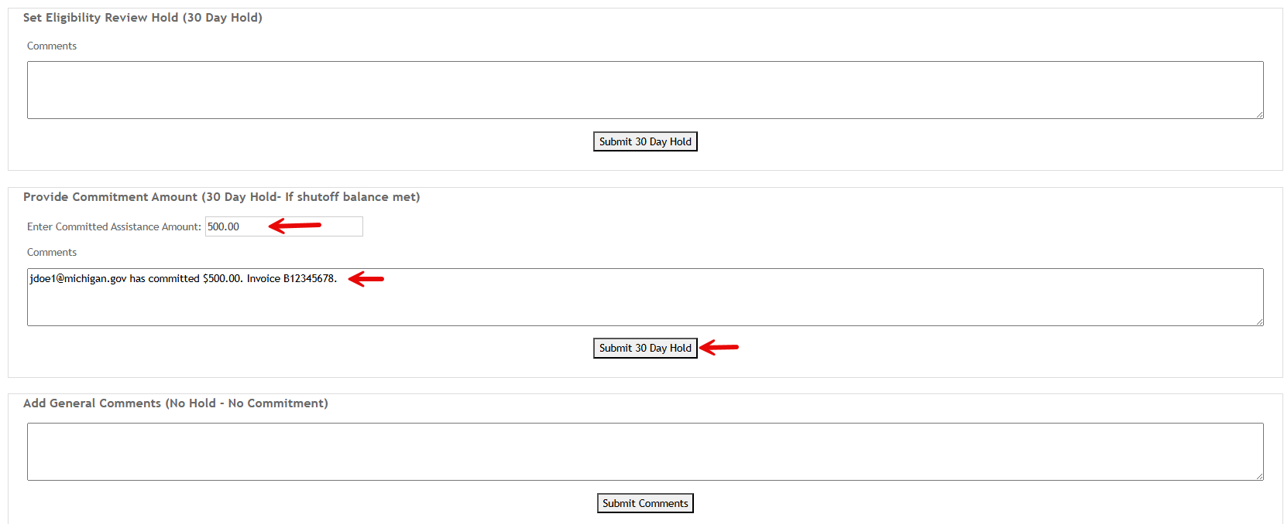
- Once you place the commitment you will see confirmation of it with your agency name, your name and amount committed. If the commitment meets or exceeds the shut off balance required to restore service, a hold will be placed. If the commitment is less than the required amount, it will be recorded in CE PASS, but no hold will be applied.

DELETE A COMMITMENT
- To delete a commitment, VOID it under the “Hold/Comments” tab.
- Find your commitment, click on the line once, then on the “View Transaction Detail” button that will appear.

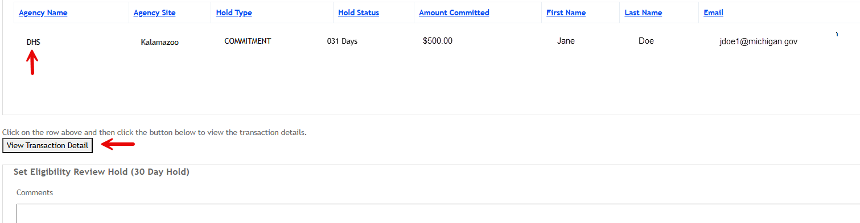
- Another box will open that says, “MODIFY COMMITMENT/COMMENTS”.
- Enter 0 for your committed amount and enter comments as to why you are deleting.
- Click “VOID HOLD”.

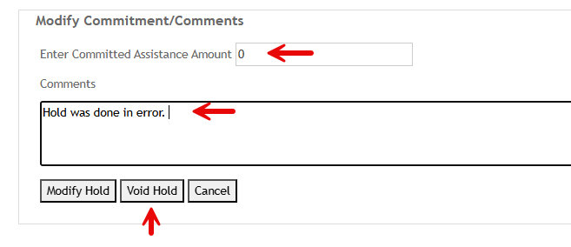
- A pop up will appear. Click “OK” to void the commitment.

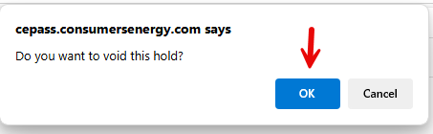
- You will then see the confirmation that your commitment was deleted. The amount you originally committed will change to zero.

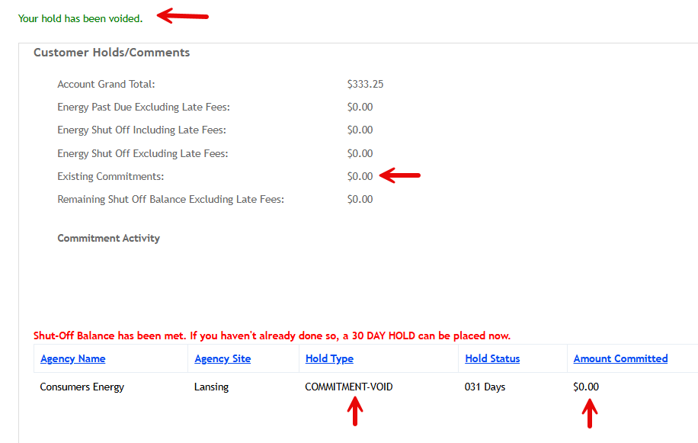
- You may now enter a new commitment if you needed.

ADD NEW USER
- In CE PASS, navigate to the Administration tab
- In the Edit Selected or Create New User update the following fields
  - Agency Site (select county from the drop down menu
  - User Role (Agency Caseworker, Agency Manager/Agency Site Administrator (both have the same role)
  - First Name
  - Last Name
  - User Name – You determine the user and it is already assigned to someone you will get an error message.
  - Email
  - Is the user a customer of Consumers Energy? You will leave at no and use the county agency address in the following fields
  - House Number
  - Street Name
  - City
  - State (defaults as Michigan)
  - Zip Code

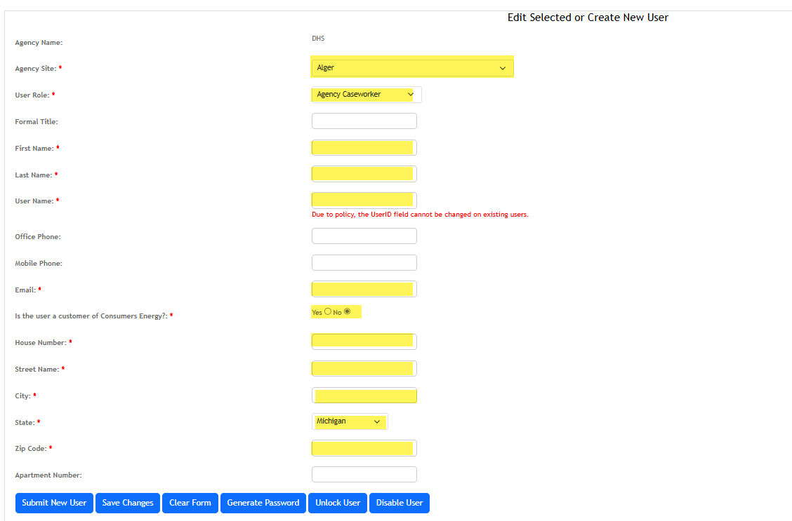
- Click on Submit New User
  - You will receive confirmation that the user was created, and an email sent with user id and a temporary password.

FAQs and Additional Information
- Debt Collection: If the move out date is more than 6 years old on the account, we can no longer collect on the debt.
- New Service: If a customer needs to start new service, in the Details tab, the “ENERGY TOTALS” section of “TOTAL BALANCE” of their previous account must be paid first.
- Service Reconnection: If a customer is disconnected, once the commitment is place, they need to call Consumers Energy Customer Service at 800-477-5050 to start reconnection. The Energy Assistance Team cannot process reconnections.
- Theft/Fraud: When an account has Theft or Fraud marked, please call the number listed in CE PASS. If you have no call back number, please leave your email address on the voicemail.
- Disconnection Policy: Customers will not be disconnected due to non-energy charges. Only charges related to energy consumption can lead to disconnection.
- Senior Customers: If a customer is a senior citizen, but their account is not reflecting that, we cannot change their account. The customer will need to call Consumers Energy Customer Service at 800-477-5050 and discuss with a customer representative.
- Customer Documents: We cannot recreate Shut-off balance letters or Client Info Statements. If time has passed and you are missing a document, reference the Itemized Statement (under “Account Reports” tab) or an old bill (under “Billing History” tab).

Revision History
Date of Revision | Description | Name of Revisor
2/15/25 | Create job aid | Melissa Benzenberg  Consuelo Gomez
2/24/25 | Edited | Tori Rombach
3/1/25 | Edited | Melissa Benzenberg
3/13/25 | Edited | Melissa Benzenberg

